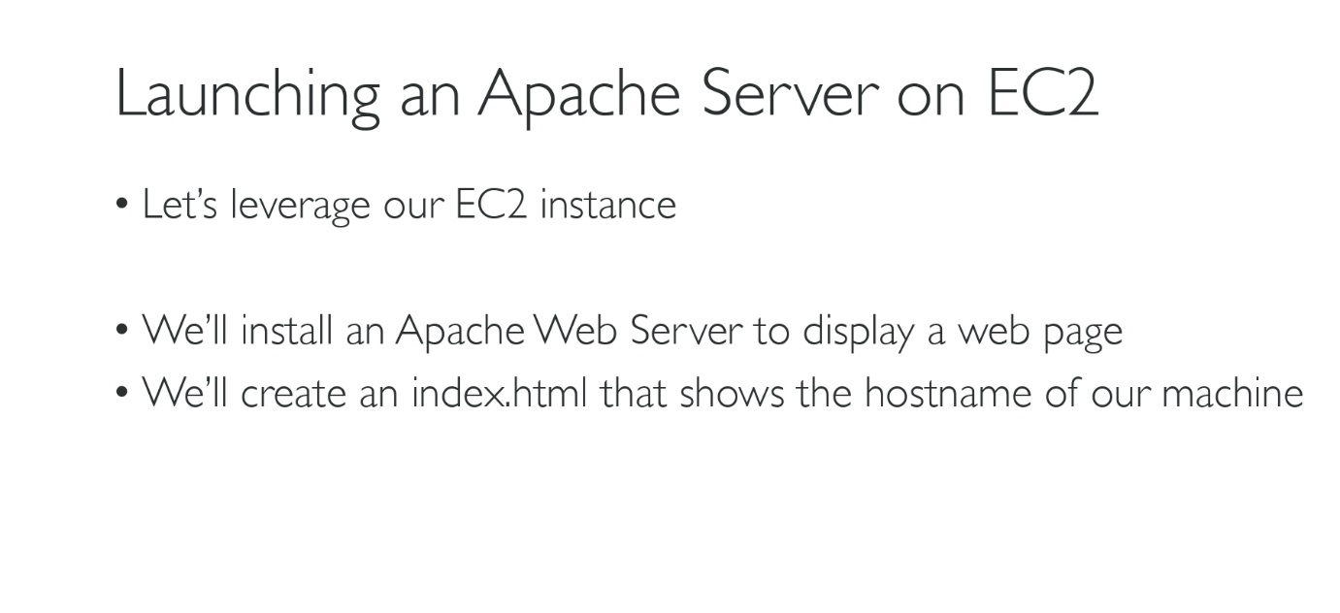

1. Log into the console using putty or ssh or Instance Connect.
2. Now type the following commands:

* sudo su 🡪 To get into the root account
* yum update -y 🡪 Updates the machine by itself and imp to keep pakgs updated.
* yum install -y httpd.x86_64 🡪 to install httpd
* systemctl start httpd.service 🡪 start the httpd service
* systemctl enable httpd.service 🡪 system will be enabled across reboots
* curl localhost:80 🡪 curl localhost:80 🡪 a html page, curl is used to load the contents of a url

1. Copy the public key and in the browser enter the following url: <http://publickey:80>
2. If problem exists then it might be the inbound setting, go to inbound rules and allow port 80 to access the publickey of your instance.
3. Go to the browser and refresh the page and you should see an apache page accessed.